**Mosip:IDA Data Generator**

**Setup Script**

**MTech 2021-22**

Nikunj:MT2021084

Sarika: MT2021118

Jaishika: MT2021058

Pragya: MT2021094

Suchi: MT2021140

Aman:MT2021013

**1.What is Mosip:**

MOSIP is an open-source platform meant for governments or international organisations to build a foundational identification system in a cost-effective way.

**2. IDA Data Generator:**

We have followed these steps guided by our mentor:

**2.1 Git Clone:**

Clone the repository <https://github.com/mosip/id-authentication>

After setting it up we found this repository has many files missing so then we cloned other repository :

<https://github.com/mosip/id-authentication/tree/1.2.0-rc1>

**2.2 Image creation:**

Project setup was successful then we created images for different services

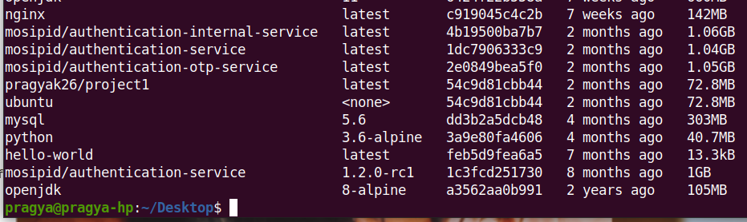

**2.3 Containerization:**

Created container for all images

Command used :docker run -i -t mosipid/authentication-internal-service

Same command for rest of the images

Then we got containers for all services:

**2.4:Files copy to host:**

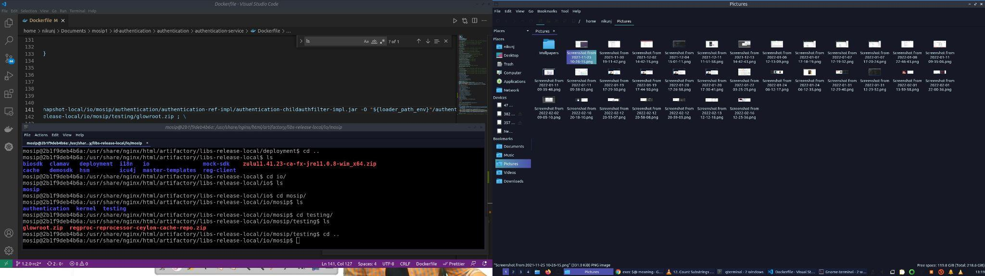

**2.5:Insert files into id-authentication:**

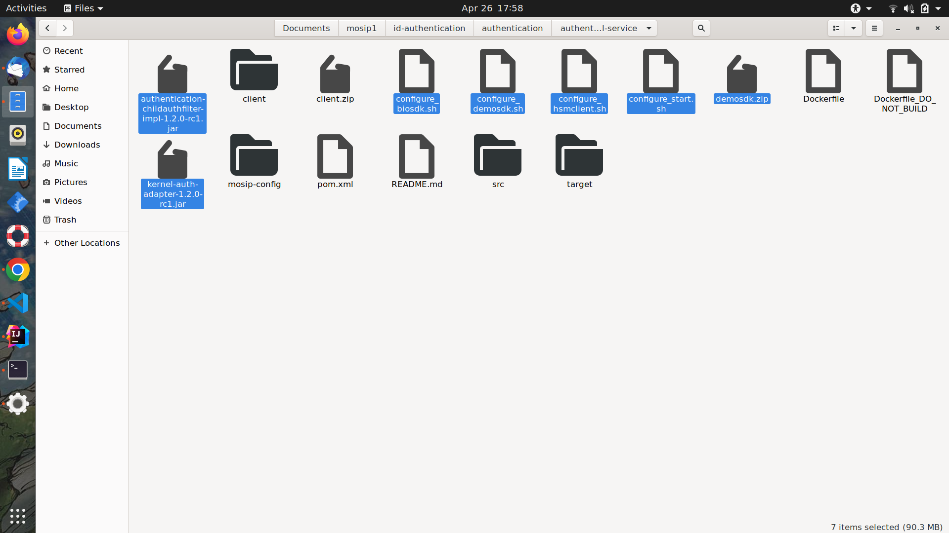



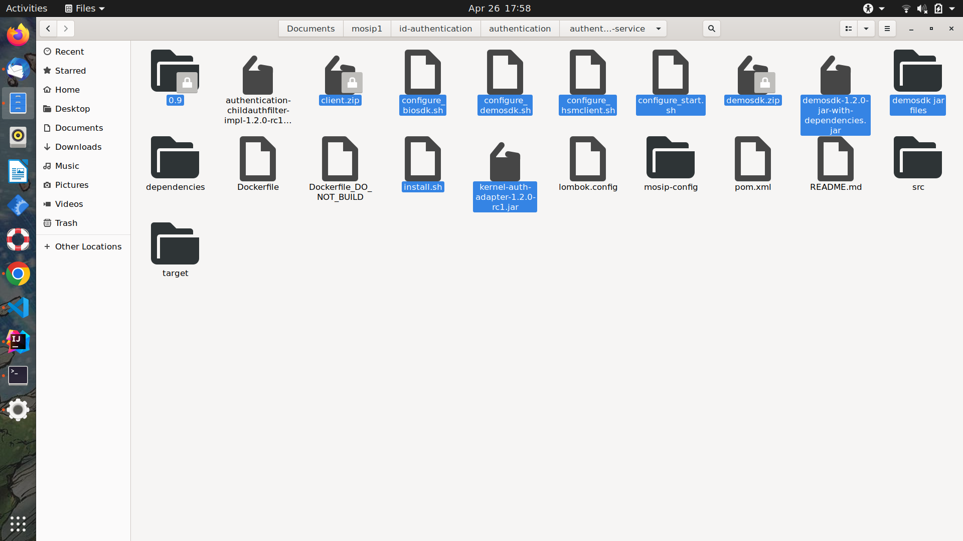

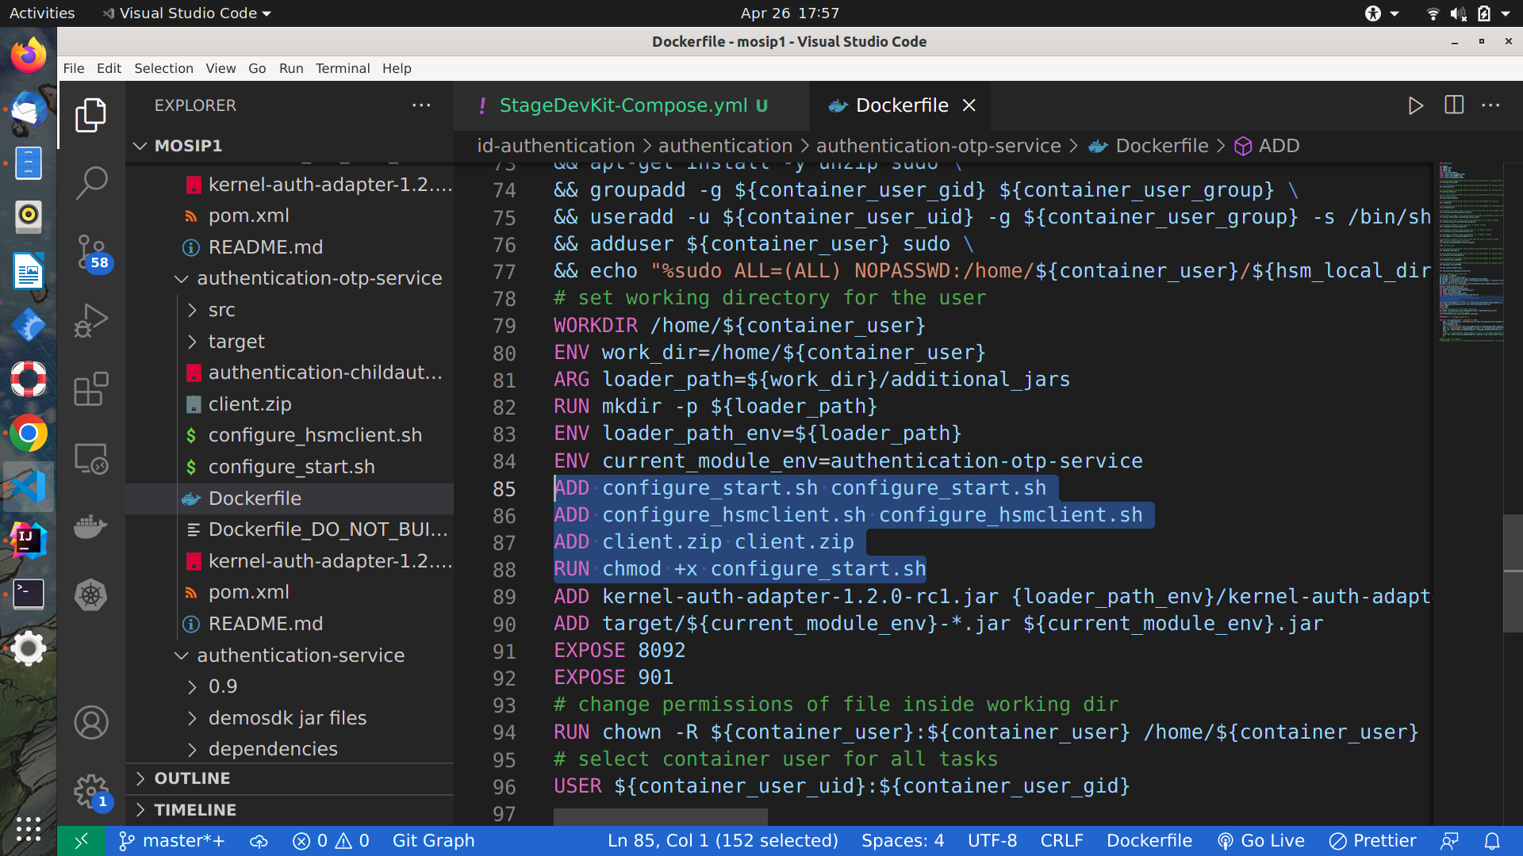

**2.6:Change the shell script accordingly**

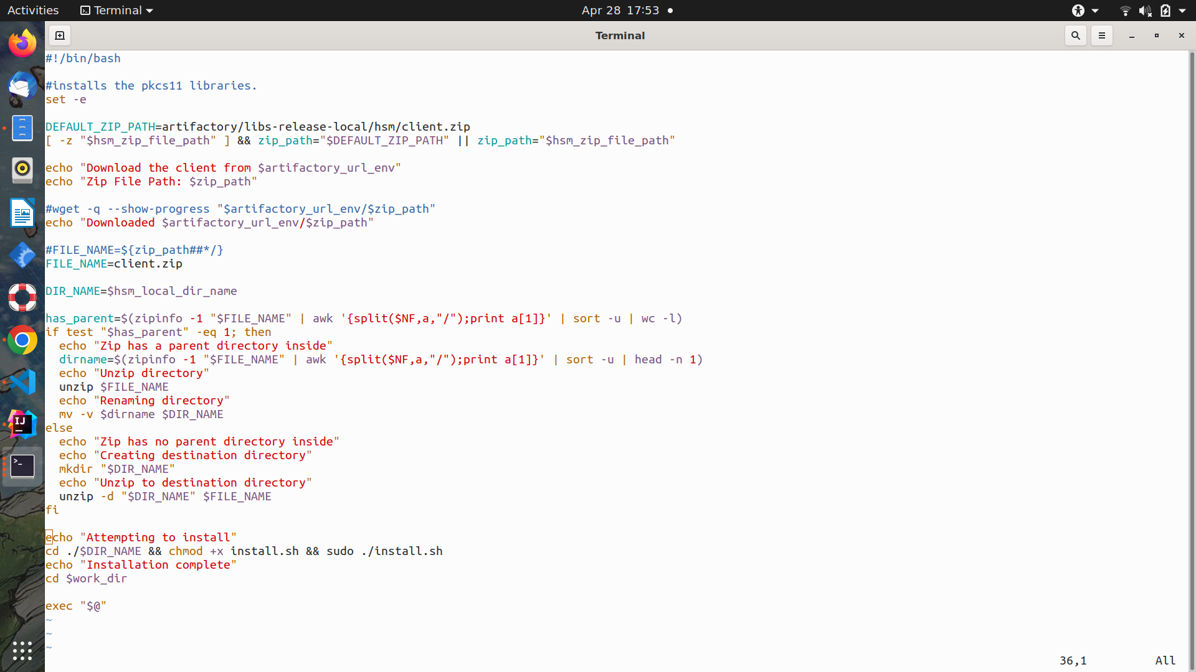

**2.8:Pulling docker image from docker-hub:**

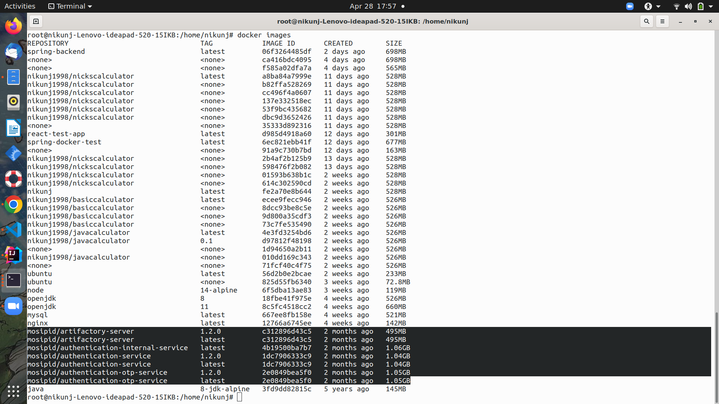

**3.Different Services:**

We have covered 3 services :

* Id-authentication
* Authentication-otp-service
* Authentication internal service

**4.Conclusion:**

This project covers a big part of devOps technologies . We got to learn about docker and